**Page Structure**

## HTML Basic Format Page Structure

The basic structure of an HTML page is laid out below. It contains the essential building-block elements (i.e. doctype declaration, HTML, head, title, and body elements) upon which all web pages are created.

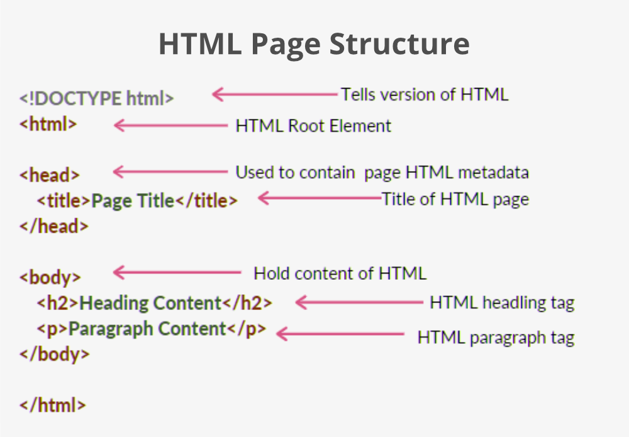

[**<DOCTYPE! html>**](https://www.geeksforgeeks.org/html-doctypes/)

1. A Document Type Declaration, or DOCTYPE for short, is an instruction to the web browser about the version of markup language in which a web page is written.
2. The doctype declaration is not case-sensitive.
3. A doctype or document type declaration is an instruction that tells the web browser about the markup language in which the current page is written. It is not an element or tag

Note: The doctype declaration refers to a Document Type Definition (DTD). It is an instruction to the web browser about what version of the markup language the page is written in. The World Wide Web Consortium (W3C) provides DTDs for all HTML versions.

[**<html>**](https://www.geeksforgeeks.org/html-html-tag/)

 This tag is used to define the root element of HTML document. This tag tells the browser that it is an HTML document. It is the second outer container element that contains all other elements within it.

[**<head>**](https://www.geeksforgeeks.org/html-head-tag/)

 This tag is used to define the head portion of the HTML document that contains information related to the document. Elements within the head tag are not visible on the front-end of a webpage.

**Organizing Content with Headings**

Headings help in defining the hierarchy and the structure of the web page content.

HTML offers six levels of heading tags, <h1> through <h6>; the lower the heading level number, the greater its importance — therefore

<h1> tag defines the most important heading,

whereas the <h6> tag defines the least important heading in the document.

By default, browsers display headings in larger and bolder font than normal text. Also, <h1> headings are displayed in largest font, whereas <h6> headings are displayed in smallest font.

<html>

<head>

<title>HTML Heading Tag</title>

</head>

<body>

<h1>Heading h1<h1>

<h2>Heading h2<h2>

<h3>Heading h3<h3>

<h4>Heading h4<h4>

<h5>Heading h5<h5>

<h6>Heading h6<h6>

</body>

</html>

**Importance of Headings**

* HTML headings provide valuable information by highlighting important topics and the structure of the document, so optimize them carefully to improve user engagement.
* Don't use headings to make your text look BIG or bold. Use them only for highlighting the heading of your document and to show the document structure.
* Since search engines, such as Google, use headings to index the structure and content of the web pages so use them very wisely in your webpage.
* Use the <h1> headings as main headings of your web page, followed by the <h2> headings, then the less important <h3> headings, and so on.

Don't use headings to make text **<big>** or **<strong>**.

[**<title>**](https://www.geeksforgeeks.org/html-body-tag/)

The <title> element defines the title of the document.

The title element is required in all HTML/XHTML documents to produce a valid document. Only one title element is permitted in a document and it must be placed within the <head> element. The title element contains plain text and entities; it may not contain other markup tags.

The title of the document may be used for different purposes. For example:

* To display a title in the browser title bar and in the task bar.
* To provide a title for the page when it is added to favorites or bookmarked.
* To displays a title for the page in search-engine results.

**<!DOCTYPE html>**

**<html lang="en">**

**<head>**

**<title>A simple HTML document</title>**

**</head>**

**<body>**

**<p>Hello World!</p>**

**</body>**

**</html>**

[**<meta>**](https://www.geeksforgeeks.org/html-body-tag/)

The <meta> tags are typically used to provide structured metadata such as a document's keywords, description, author name, character encoding, and other metadata. Any number of meta tags can be placed inside the [head section](https://www.tutorialrepublic.com/html-tutorial/html-head.php) of an HTML document.

Metadata will not be displayed on the web page, but will be machine parsable, and can be used by the browsers, search engines like Google or other web services.

*Declaring Character Encoding in HTML*

<meta charset="utf-8">

Note: UTF-8 is a very versatile and recommended character encoding to choose. However, if this is not specified, then the default encoding of the platform is used.

*Defining the Author of a Document*

**<meta name="author" content="Dipak Maiti">**

*Keywords and Description for Search Engines*

Some search engines use metadata especially keywords and descriptions to index web pages; however this may not necessarily be true. Keywords giving extra weight to a document's keywords and description provide a short synopsis of the page.

<head>

<title>Defining Keywords and Description</title>

<meta name="keywords" content="HTML, CSS, javaScript">

<meta name="description" content="Easy to understand tutorials and references on HTML, CSS, javaScript and more...">

</head>

**Importance of Title Tag in SEO**

Title gives users a quick insight about the content available on a web page. This is often the primary piece of information used to decide which result to click on in the Search Engine Results Pages (SERP). That's why the <title> tag is considered as the most important element for Search Engine Optimization (SEO), so make sure each page of your website has a unique and descriptive title.

Here are a few tips for creating titles of the web pages:

* Keep your title brief and descriptive that is relevant to the content of your pages.
* Avoid keyword stuffing i.e. repeating the same words or phrases multiple times.
* Avoid repeated titles. Create unique titles for each pages of your site.

**Importance of Meta Description Tag in SEO**

The <meta> description tag is used to provide a brief and descriptive summary of web page's content. Search engine often use the meta description of a page in search results snippets which is appear below the page title. Appropriate meta descriptions can help improve your website click through rate.

Here are a few tips for creating meta descriptions for the web pages:

* Make sure that every page of your site has a meta description.
* Create concise and high-quality descriptions that accurately describe your page.
* Make sure each page on your website has a different meta description.

*Configuring the Viewport for Mobile Devices*

<meta name="viewport" content="width=device-width, initial-scale=1">

You can use the viewport meta tag to display the web pages correctly on mobile devices.

Without a viewport meta tag, mobile browsers render the web pages at typical desktop screen widths, and then scale it down to fit the mobile screen. As a result, it requires pinch-and-zoom to view the web page properly in mobile devices, which is very inconvenient.

The following demonstration shows two web pages — one with viewport meta tag and other without viewport meta tag set. Open these links on mobile devices to see how it works.

The width=device-width key-value pair inside the content attribute sets the width of the viewport to same as the screen width of the device, whereas the initial-scale=1 sets the initial scale or zoom level to 100% when the page is first loaded by the browser.

[**<body>**](https://www.geeksforgeeks.org/html-body-tag/)

 The body tag is used to enclose all the visible content of a webpage. In other words, the body content is what the browser will show on the front end.

<!DOCTYPE html>

<html>

<!-- Head Section content -->

<head>

<!-- Page title -->

<title>Basic Web Page</title>

</head>

<!-- Body Section content -->

<body>

<!-- Used to display heading content -->

<h1>We are learning html</h1>

<!-- Used to display paragrapg content -->

<p>Computer science is a important subject </p>

</body>

</html>

[**<para>**](https://www.geeksforgeeks.org/html-body-tag/)

**Creating Paragraphs**

Paragraph element is used to publish text on the web pages.

Paragraphs are defined with the <p> tag. Paragraph tag is a very basic and typically the first tag you will need to publish your text on the web pages.

<!DOCTYPE html>

<html lang="en">

<head>

<title>Creating Paragraphs in HTML</title>

</head>

<body>

<p>This is a paragraph.</p>

<p>This is another paragraph.</p>

</body>

</html>

**Creating Line Breaks**

The <br> tag is used to insert a line break on the web page.

Since the <br> is an [empty element](https://www.tutorialrepublic.com/html-tutorial/html-elements.php#empty-elements), so there is no need of corresponding </br> tag.

<!DOCTYPE html>

<html lang="en">

<head>

<title>Inserting Line Breaks in HTML</title>

</head>

<body>

<p>This is a paragraph <br> with line break.</p>

<p>This is <br>another paragraph <br> with line breaks.</p>

</body>

</html>

Note: Don't use the empty paragraph i.e. <p></p> to add extra space in your web pages. The browser may ignore the empty paragraphs since it is logical tag. Use the CSS margin property instead to adjust the space around the elements.

**Creating Horizontal Rules**

You can use the <hr> tag to create horizontal rules or lines to visually separate content sections on a web page. Like <br>, the <hr> tag is also an empty element.

<!DOCTYPE html>

<html lang="en">

<head>

<title>Creating Horizontal Lines in HTML</title>

</head>

<body>

<p>This is a paragraph.</p>

<hr>

<p>This is another paragraph.</p>

</body>

</html>

**Managing White Spaces**

Normally the browser will display the multiple spaces created inside the HTML code by pressing the space-bar key or tab key on the keyboard as a single space. Multiple line breaks created inside the HTML code through pressing the enter key is also displayed as a single space.

The following paragraphs will be displayed in a single line without any extra space:

<!DOCTYPE html>

<html lang="en">

<head>

<title>White Space Collapsing in HTML</title>

</head>

<body>

<p>This paragraph contains multiple spaces in the source code.</p>

<p>

This paragraph

contains multiple tabs and line breaks

in the source code.

</p>

</body>

</html>

nsert &nbsp; for creating extra consecutive spaces, while insert <br> tag for creating line breaks on your web pages, as demonstrated in the following example:

<!DOCTYPE html>

<html lang="en">

<head>

<title>Preserving White Space in HTML</title>

</head>

<body>

<p>This paragraph has multiple&nbsp;&nbsp;&nbsp;spaces.</p>

<p>This paragraph has multiple<br><br>line<br><br><br>breaks.</p>

</body>

</html>

**Defining Preformatted Text**

Sometimes, using &nbsp;, <br>, etc. for managing spaces isn't very convenient. Alternatively, you can use the <pre> tag to display spaces, tabs, line breaks, etc. exactly as written in the HTML file. It is very helpful in presenting text where spaces and line breaks are important like poem or code.

The following example will display the text in the browser as it is in the source code:

<!DOCTYPE html>

<html lang="en">

<head>

<title>HTML Preformatted Text</title>

</head>

<body>

<pre>

Twinkle, twinkle, little star,

How I wonder what you are!

Up above the world so high,

Like a diamond in the sky.

</pre>

</body>

</html>

Tip: Text within the <pre> element is typically rendered by the browsers in a monospace or fixed-width font, such as Courier, but you can override this using the CSS font property.

**Writing Comments in HTML**

An HTML comment begins with <!--, and ends with -->

<!-- This is an HTML comment -->

<!-- This is a multi-line HTML comment

that spans across more than one line -->